Candidate Name : Jitendra Rajendra Jivrak MCA II

PART 1: Problem Statement
Problem Statement : Alert Triage Workflow: Show how a security engineer might investigate and resolve a cloud security alert.
Cloud security platforms generate hundreds of alerts daily across Kubernetes clusters, cloud workloads, and containers. Security engineers often struggle with alert fatigue due to duplicate, low-context, and unprioritized alerts.
This leads to:
- Delayed response to critical threats
- MTTR - Increased Mean Time to Resolve
- Inefficient investigation workflow
- Higher risk of production impact
There is a need for a simple alert triage workflow that helps security engineers prioritize, investigate, and resolve security alerts efficiently.

PART 2: User Persona

Primary Persona : Security Engineer
Environment:
- Manages multi-cloud setup like AWS, GCP, Azure
- Handles Kubernetes security alerts
- Uses multiple dashboards daily
Goals:
- Identify real threats quickly
- Reduce complexity from duplicate alerts
- Assign and track alert ownership
- Resolve issues before Service level Agreements SLA breach
Pain Points:
- Too many alerts with no context
- No prioritization beyond severity
- Manual investigation steps
- No workflow tracking

PART 3: My 3 Figma Screens

Screen 1: Alerts Dashboard

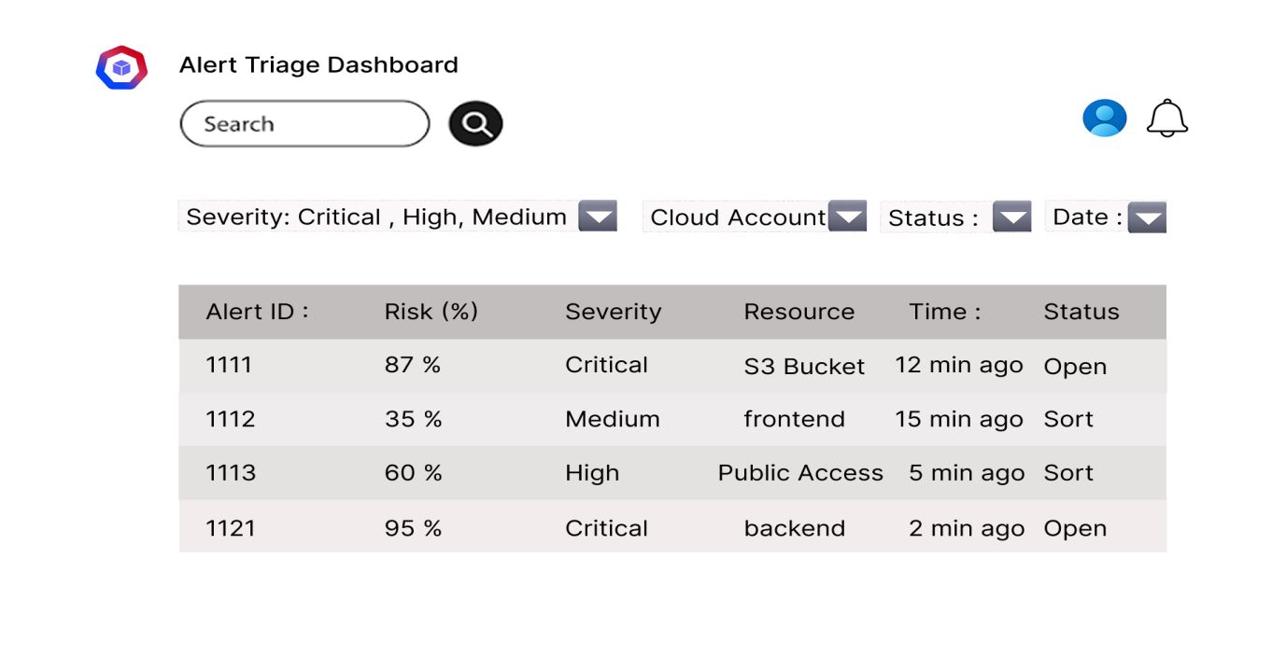
Annotations :
- Risk Score improves prioritization beyond severity
- Filters reduce investigation time
- Grouping similar alerts reduces noise
Screen 2: Alert Detail View

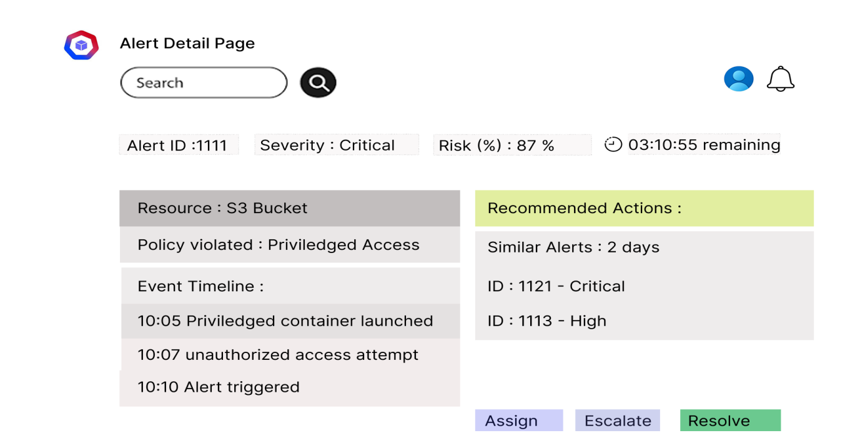

Annotations:
- Contextual information centralized
- SLA timer ensures accountability
- Recommended remediation reduces decision delay

Screen 3: Workflow Board

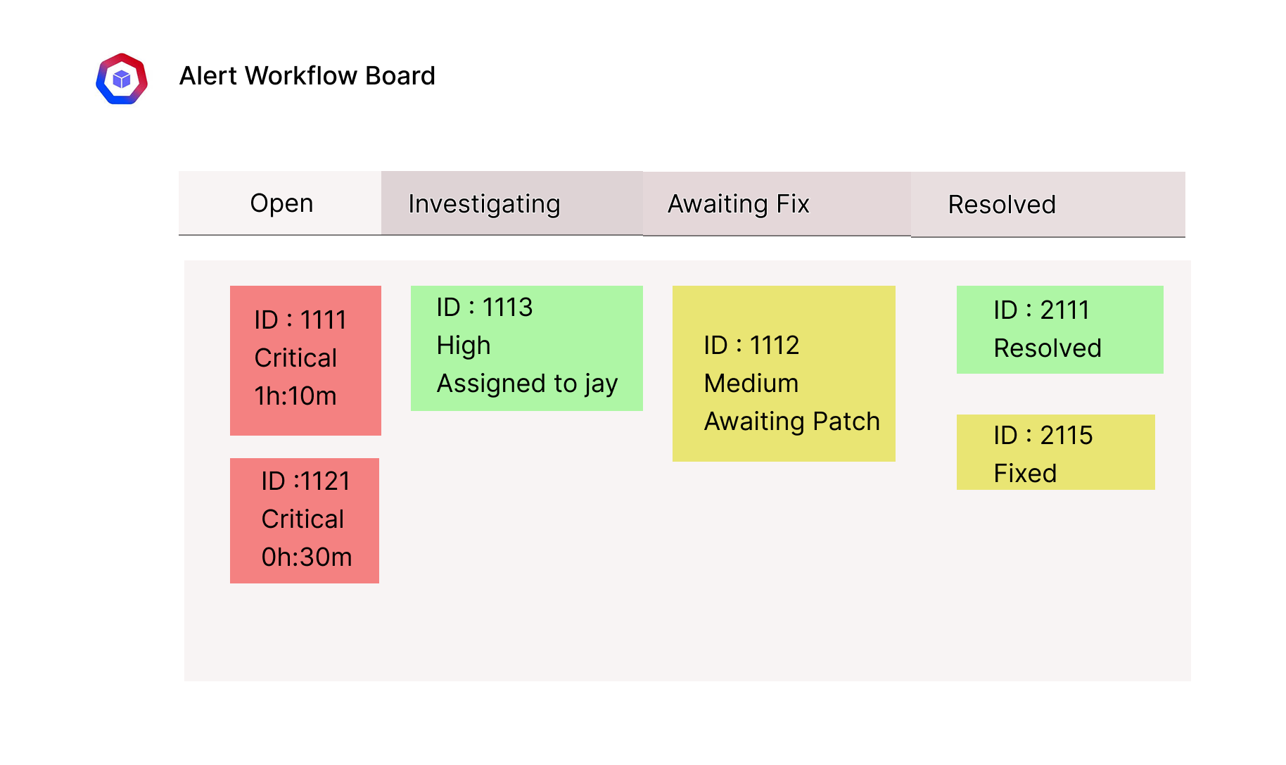
Annotations:
- Kanban view improves visibility
- Ownership tracking reduces backlog
- Status tracking prevents SLA breaches

PART 4 : Design Rationale
a structured workflow approach is :
Identify → Investigate → Resolve
- The dashboard focuses on quick scanning and prioritization.
- The detail view centralizes investigation context to reduce tool switching.
- The workflow board introduces transparency and ownership tracking.
The overall design minimizes load and supports rapid decision-making in high-pressure security environments.

PART 5 : Feature Prioritization
Prioritization Approach: RICE Framework

MVP Features:
- Centralized alert dashboard
- Risk scoring mechanism
- Alert detail investigation page
- Assignment and status tracking

Phase 2 Enhancements:
- AI-based alert clustering
- Predictive risk scoring
- Integration with CI/CD pipelines

PART 6 : Success Metrics
The effectiveness of this solution can be measured by:
- 30% reduction in MTTR
- 40% reduction in duplicate alerts
- Increase in alerts resolved within SLA
- Reduction in alert backlog
- Improved user satisfaction score

PART 7 : Development Discussion Points
To implement this solution, the following technical considerations are required:
- Cloud alert ingestion pipeline
- Risk scoring algorithm (severity + asset criticality)
- Role-based access control (RBAC)
- SLA tracking microservice
- Alert clustering logic
- Audit logging system

